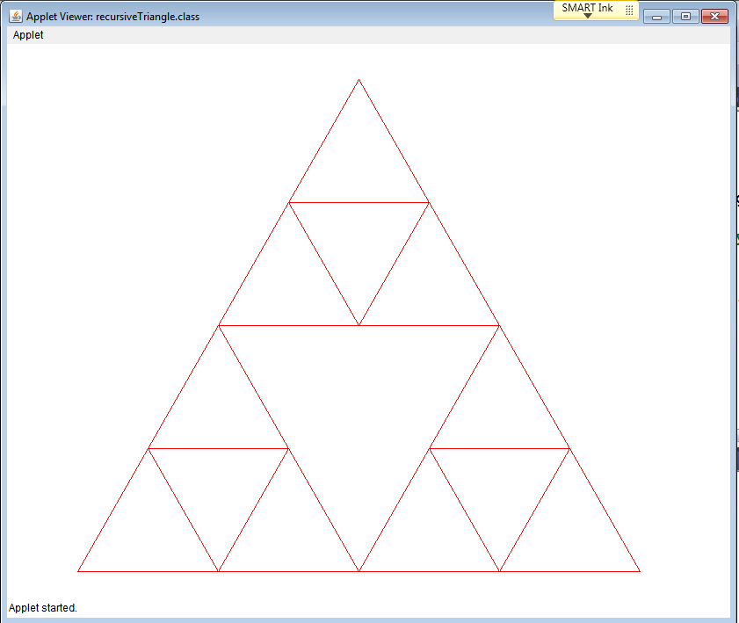
Triangle Fractal Lab
by Kevin Hayes
Introduction
If you were going to describe how to draw a triangle you could:
- Create 3 sets of x, y points
- Start at one set draw a segment to the 2 other points & then back to the original
- You now have 4 triangles 1 large center and 3 smaller
- Inside of the smaller triangles draw a triangle using the midpoints
- Keep repeating the process, drawing smaller and smaller triangles until the triangles are too small to draw
This process of repeating the same design at a continually decreasing scale is an example of a Fractal. Using fractals to draw can give some interesting and beautiful patterns. In this assignment we will use a recursive function to create a fractal design.

Procedure
Here is some sample code is provided:

Requirements
- Extend the sample code to write an applet that displays a fractal triangle.
- Define the necessary instance variables for the Applet & the Triangle method.
  - the drawPlolyline method takes a set of x, y cordinates
    - xstart, xpoint1, xpoint2, xstart (to draw back to origin)
    - ystart, ypoint1, ypoint2, ystart (to draw back to origin)
    - length of Array of points
- Add any methods you may need (calculate midpoints or distance)

Turn in: Print Triangle Method
I will check your output of Recursive Triangle and initial printed code
Extensions:
●do not choose midpoints of each triangle, make recursive calls asymmetrical triangles
●program a square (Sierpinski Carpet vs Triangle)
●program another recursive design / fractle

